## Safety

Family

*Care*

**Independence**

Help

# Protection

## Peace of Mind



***“One thing I have learned through all this*** is that no person, male or female, living alone should do so without wearing a simple little (medical alert) device... You don’t have to be OLD to need it, just living alone is enough. Always remember -IT COULD HAPPEN TO YOU TOO.”

### Your Independence

You need the independence to live like you are used to -Our medical alert simply provides peace of mind for you and those who care about you the most -anytime, 24 hours a day.

### Your Protection

Our system is the most comprehensive and advanced medical alert available today. This system is designed for speed, accuracy, and affordability.

### Your Family

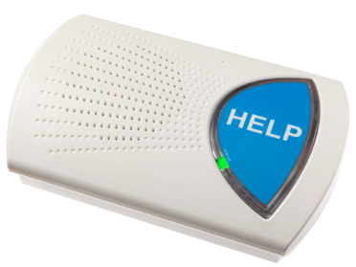Our system allows your family and friends a greater sense of freedom as well. They can be contacted immediately should any emergency occur, as well as any

health care services of your choice.

#### If one or more of these apply to you or a loved one our medical alarm system may be your best source of help without giving up your independence.

**Home alone for more than 2 hours at a time**

Studies show that 60% of falls happen in the home, but seniors who seek immediate help for their injuries have a better chance of returning to a normal independent lifestyle.

#### Age 65+

According to the CDC (Center for Disease Control), every year one in three adults over 65 years of age experiences a fall. The Good news is that a lot of injuries that are caused by a fall could be treated if help is sought out immediately.

**In need of a source for help at a low cost**

The national average cost for Assisted Living Facilities is over $3,000 a month. With our medical alarm system, you can get the security and the independence for a substantially lower cost.

**Why Cell Phones Are Not the Solution**

**Cell Phone(s):**

→Cannot be used in the bath or shower

→Are not typically carried around the home

→Have a shorter battery life

→Have to be charged daily

→Dialing 911 requires pressing more buttons than with the Rescue Alert

**Frequently Asked Questions**

1. **Who does the Response Center Call?**

We call 911, family, neighbors, and/or friends.

1. **Do I have to have a medical emergency to use my medical alarm?**

No -Our medical alarm system provides help to thousands of people every day in a variety of different ways.

1. **Will my system work with DSL, VoIP, or Cable Telephone System?**

Yes-Ours is the only system designed specifically to work with all of these telephone connecations.

**There are 3 Components to your Medical Alert System**

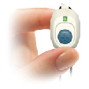**Your Personal Help Button (PHB)** is a waterproof button that can be worn around the neck or wrist at all times. If help is needed, you simply press the button.

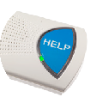**The Base Unit** is activated once the PHB is pressed. It will automatically become a source for Two-Way Voice communication with the Emergency Response Center.

**An Emergency Response Center** Dispatcher will speak over the Unit to ask if help is needed. This Dispatcher will obtain help catered to the situation.

*If the Response Center cannot make voice contact with the customer, they will still call for help.